Use Case Diagrams

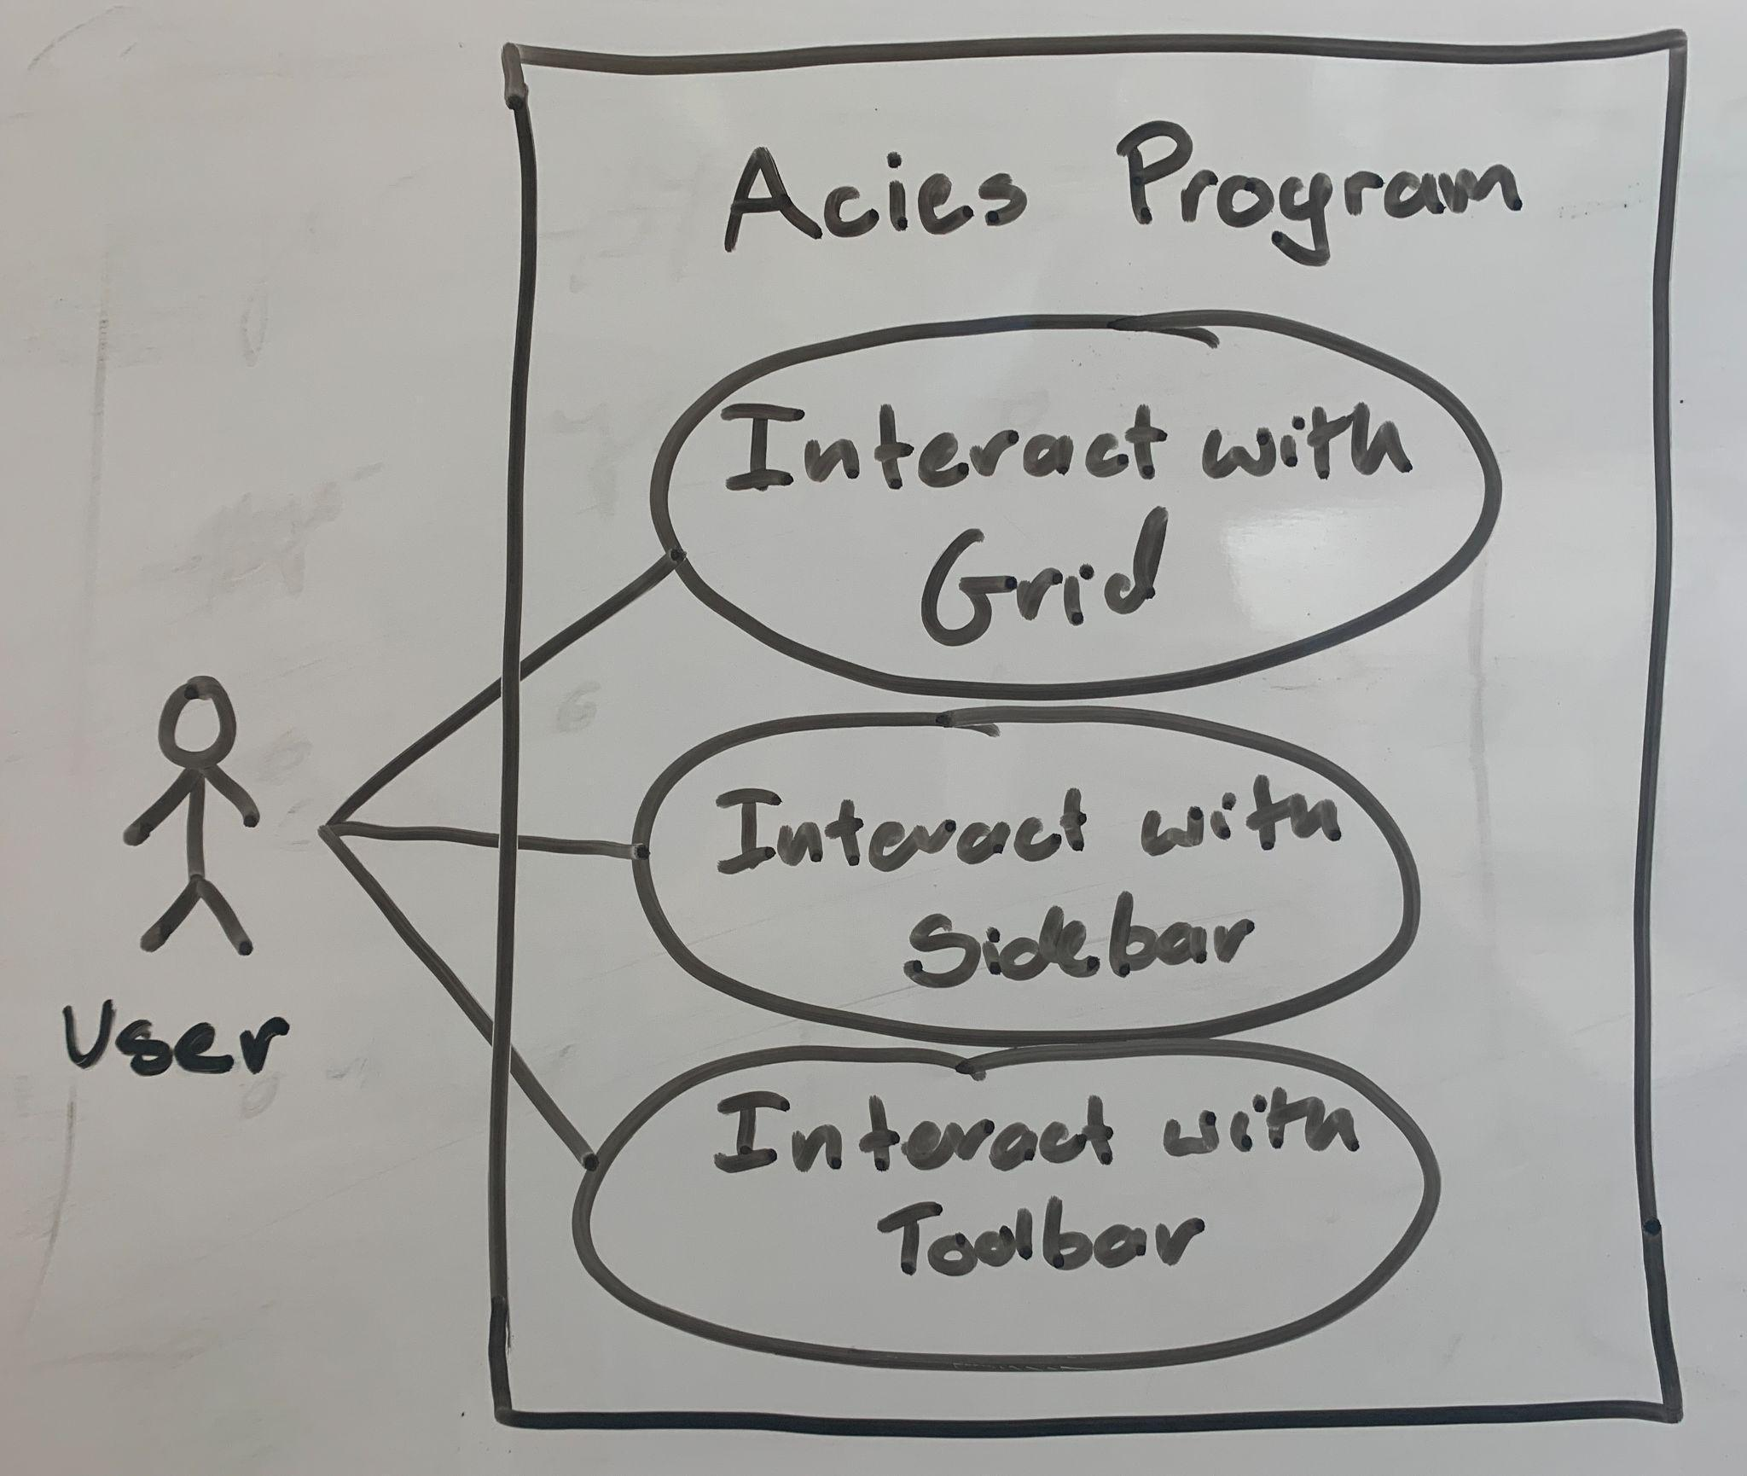

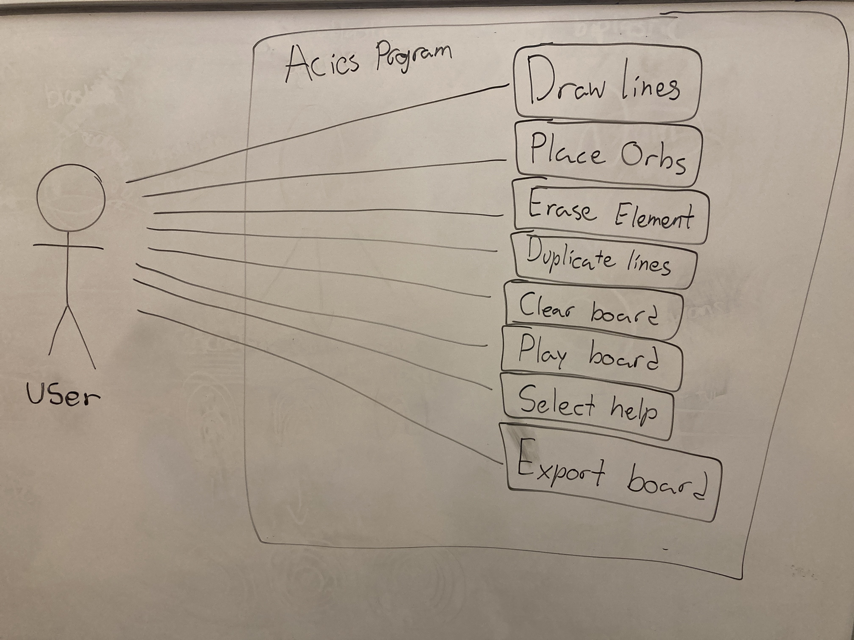

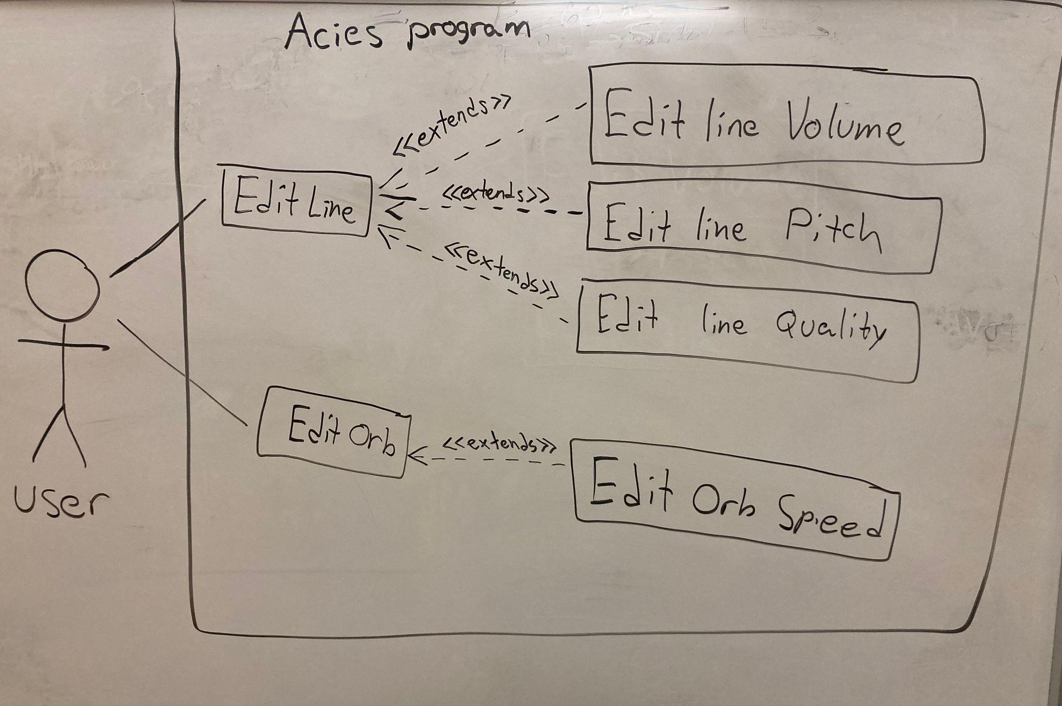

Use Case Descriptions

**Use case:** Interact with Sidebar

**Actors:** Users

**Goals:** Adjust values of either lines or orbs.

**Preconditions:** A line or orb must be selected in order to adjust its values.

**Summary:** One possibility for interacting with the sidebar is adjusting line volume. After selecting the orb/line, this is achieved simply by dragging the desired slider to a new value.

**Related use cases—**

* **none**

**Steps:**

| Actor actions: | System Responses: |
| --- | --- |
| 1. Drag incremental slider to desired value | 2. Slider highlight added |
|  | 3. Corresponding slider value adjusted  accordingly |
| 4. Select any other button or area of page | 5. Slider highlight removed |

**Post-Conditions:** The system is the same as it was beforehand except the selected line/orb has a different value.

**Use case:** Edit Orb Speed

**Actors:** Users

**Goals:** Adjust orb speed to be faster or slower

**Preconditions:** An orb must be selected in order to adjust its values.

**Summary:** After being selected, orb speed is changed simply by dragging the slider to a desired position.

**Related use cases—**

**Extension of:**

* Edit Orb

**Steps:**

| Actor actions: | System Responses: |
| --- | --- |
| 1. Drag incremental orb speed slider | 2. Orb speed slider highlight added |
|  | 3. Orb speed changed accordingly |
| 4. Select any other button or area of page | 5. Orb speed slider highlight removed |

**Post-Conditions:** The system is the same as it was beforehand except the selected orb has a different speed with which it will travel when the design is played.

**Use case:** Draw Lines

**Actors:** Users

**Goals:** Draw lines on the grid on which orbs will travel

**Preconditions:** Either 1) the “Draw” tool must be selected, or 2) the user must left click to draw lines

**Summary:** When the user left-clicks on the grid, it will create a line at that point with values equal to the most recent line created or edited.

**Related use cases—**

**- none**

**Steps:**

| Actor actions: | System Responses: |
| --- | --- |
| 1. User positions mouse over a spot between two dots on the grid |  |
| 2. User left clicks | 3. System adds a line between the two dots that are nearest to the cursor. |
|  | 4. The line adopts the values of the line most recently created or edited |

**Post-Conditions:** The system is the same as it was beforehand except there is a new line where the user clicked.

**Use case:** Edit Line

**Actors:** Users

**Goals:** Make the sidebar display the line values of a selected line

**Preconditions:** “Erase” or “Draw” tool must not be selected

**Summary:** When the ““Erase” and “Draw” tools are not selected, when the user clicks on a line on the grid, the line’s values will show in the sidebar.

**Related use cases—**

**Extended by:**

* Edit line Volume
* Edit Line Pitch
* Edit Line Quality

**Steps:**

| Actor actions: | System Responses: |
| --- | --- |
| 1. User positions mouse over an existing line on the grid |  |
| 2. User left clicks | 3. System detects that the click is on the grid and that “Erase” and “Draw” tools are not selected. |
|  | 4. Opens the sidebar menu to the values of the line that connects the nearest two points on the grid to the cursor. |

**Post-Conditions:** The system is the same as it was beforehand except the selected line values are open in the sidebar menu.

**Use case:** Edit Line Volume

**Actors:** Users

**Goals:** Increase or decrease the volume of a line

**Preconditions:** The user must have selected a line to edit

**Summary:** When a line is selected, by adjusting the volume slider in the sidebar panel, its volume can be increased or decreased

**Related use cases—**

**Extension of:**

* Edit Line

**Steps:**

| Actor actions: | System Responses: |
| --- | --- |
| 1. User clicks on the volume slider to set it to a new position. | 2. System updates the volume parameter of the selected line to match the slider value. |

**Post-Conditions:** The system is the same as it was beforehand except the selected line has a new volume value.

**Use case:** Edit Line Pitch

**Actors:** Users

**Goals:** Increase or decrease the pitch of a line

**Preconditions:** The user must have selected a line to edit

**Summary:** When a line is selected, by adjusting the volume slider in the sidebar panel, its pitch can be increased or decreased

**Related use cases—**

**Extension of:**

* Edit Line

**Steps:**

| Actor actions: | System Responses: |
| --- | --- |
| 1. User clicks on the pitch slider to set it to a new position. | 2. System updates the pitch parameter of the selected line to match the slider value. |

**Post-Conditions:** The system is the same as it was beforehand except the selected line has a new pitch value.

**Use case:** Edit Line Quality

**Actors:** Users

**Goals:** Increase or decrease the quality of a line

**Preconditions:** The user must have selected a line to edit

**Summary:** When a line is selected, by adjusting the quality slider in the sidebar panel, its quality can be increased or decreased

**Related use cases—**

**Extension of:**

* Edit Line

**Steps:**

| Actor actions: | System Responses: |
| --- | --- |
| 1. User clicks on the quality slider to set it to a new position. | 2. System updates the quality parameter of the selected line to match the slider value. |

**Post-Conditions:** The system is the same as it was beforehand except the selected line has a new quality value.

**Use case:** Duplicate Lines

**Actors:** Users

**Goals:** Duplicate selected blocks of grid

**Preconditions:** This button can be pressed at any state in the application

**Summary:** When the “Duplicate” button is clicked, after the user drags their mouse over a rectangular area of the grid, they can click once more to duplicate their selected block wherever their mouse is.

**Related use cases—**

* **none**

**Steps:**

| Actor actions: | System Responses: |
| --- | --- |
| 1. Click “Duplicate” button | 2. “Duplicate” button highlight added. |
|  | 3. Sidebar disappears**.** |
| 4. Drag mouse (hold left click) on grid to encompass all desired lines to be duplicated. | 5. Highlight lines within the user’s area of selection. |
| 6. Let go of the mouse; stop dragging. | 7. Selected lines remain highlighted. |
| 8. Position the mouse on the dot at which the actor would like to paste the top left hand corner of their rectangular selection. |  |
| 9. Left click to place duplicated lines. | 10. If placed in a valid location with no intersections, draw all of the lines in the new location. |
|  | 11. Remove the “Duplicate Block” button highlight. |

**Post-Conditions:** The new lines will be added to the grid in the new location. The sidebar will be hidden.

**Use case:** Select Help

**Actors:** Users

**Goals:** To open a link to a website of frequently asked questions (with a contact email at the bottom) so that the user’s problem may be resolved.

**Preconditions:** This button can be pressed at any state in the application

**Summary:** After being selected, opens the user’s browser to the FAQ page.

**Related use cases—**

* **none**

**Steps:**

| Actor actions: | System Responses: |
| --- | --- |
| 1. Click “Help” button | 2. Opens the user’s browser to the FAQ page (on GitHub) |

**Post-Conditions:** The system is the same as it was before pressing the “Help” button.

**Use case:** Play Board

**Actors:** Users

**Goals:** To play the creation by setting the orbs into motion, then stop and reset orb locations

**Preconditions:** This button can be pressed at any state in the application

**Summary:** After pressing “Play”, the orbs are set into motion, and the user cannot draw or erase lines or orbs on the grid. When pressed again, the orbs reset to their original position and stop movement

**Related use cases—**

* **none**

**Steps:**

| Actor actions: | System Responses: |
| --- | --- |
| 1. Press “Play” button | 2. Highlight added to the “Play” button. |
|  | 3. Orbs begin moving along lines and playing their line's sound whenever they hit a corner. |
| 4. User interacts with the grid or toolbar. | 5. Resets the board and pauses the simulation to allow for editing. |

**Post-Conditions:** The system is the same as it was before pressing the “Play” button.

**Use case:** Erase Element

**Actors:** Users

**Goals:** Erase lines on the grid

**Preconditions:** This button can be pressed at any state in the application

**Summary:** After being pressed, any lines on the grid that are left-clicked will be removed. They will not open the sidebar to their values when clicked in this mode. Erase mode will be exited when the “Erase” button is clicked again.

**Related use cases—**

* **none**

**Steps:**

| Actor actions: | System Responses: |
| --- | --- |
| 1. Click “Erase” button | 2. “Erase” button highlight added. |
| 3. Click on a line or orb. | 4. The line or orb that was clicked on is removed. |
| 5. Select any other button or area of page | 6. "Erase" button highlight is removed. |

**Post-Conditions:** The system is the same as it was beforehand except the selected lines have been removed.

**Use case:** Export Board

**Actors:** Users

**Goals:** Allow users to download the grid to save or share their creation

**Preconditions:** This button can be pressed at any state in the application

**Summary:** Clicking “Export” will provide the user with a copy-and-paste string that they can send to their friends to load the creation they made

**Related use cases—**

* **none**

**Steps:**

| Actor actions: | System Responses: |
| --- | --- |
| 1. Click “Export” | 2. Copies to the clipboard a string representing all of the lines and orbs in the grid and their values. |
|  | 3. Pops up a message in the middle of the screen that indicates such, “Copied to Clipboard” |

**Post-Conditions:** The system is the same as it was beforehand.